Resource Limits

What are resource limits?

One of the challenges of every distributed system designed to share resources between applications, like Kubernetes, is, paradoxically, how to properly share the resources. When Kubernetes schedules a Pod, it’s important that the containers have enough resources to actually run. If you schedule a large application on a node with limited resources, it is possible for the node to run out of memory or CPU resources and for things to stop working!

Requests and limits are the mechanisms Kubernetes uses to control resources such as CPU and memory. Requests are what the container is guaranteed to get. If a container requests a resource, Kubernetes will only schedule it on a node that can give it that resource. Limits, on the other hand, make sure a container never goes above a certain value. The container is only allowed to go up to the limit, and then it is restricted.

CPU
CPU resources are defined in millicores. If your container needs two full cores to run, you would put the value “2000m”. If your container only needs ¼ of a core, you would put a value of “250m”.

Memory
Memory resources are defined in bytes. Normally, you give a mebibyte value for memory (this is basically the same thing as a megabyte), but you can give anything.
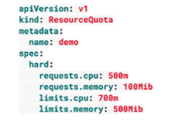
requests.cpu is the maximum combined CPU requests in millicores for all the containers in the Namespace. In the above example, you can have 50 containers with 10m requests, five containers with 100m requests, or even one container with a 500m request. As long as the total requested CPU in the Namespace is less than 500m!
requests.memory is the maximum combined Memory requests for all the containers in the Namespace. In the above example, you can have 50 containers with 2MiB requests, five containers with 20MiB CPU requests, or even a single container with a 100MiB request. As long as the total requested Memory in the Namespace is less than 100MiB!
limits.cpu is the maximum combined CPU limits for all the containers in the Namespace. It’s just like requests.cpu but for the limit.
limits.memory is the maximum combined Memory limits for all containers in the Namespace. It’s just like requests.memory but for the limit.
Hands On – Testing a Resource Limit
I. Create a new namespace with the imperative command
Let’s first create a new namespace and then verify it exists using the kubens command. Notice the default namespace will be highlighted yellow as that's the current namespace you’re in.
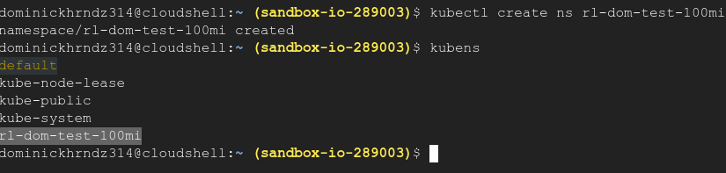
II. Create a memory limit of 100mi for the namespace
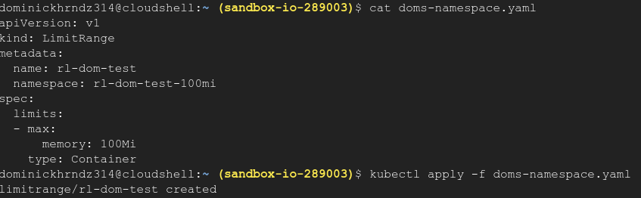
Now, we can edit the namespace to have a resource memory limit of 100 mi.
III. Create a pod with a memory request of 100mi, verify the error in the logs.
Last, lets create a pod that is asking for over 100mi of memory. If our resource limit is working in the namespace, we should receive an error.

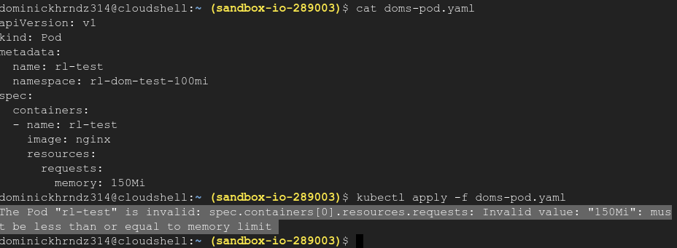
If you received this error, then you have completed this training.

